Ideation Phase Empathize & Discover

Date | 13 July 2026
Team ID
Project Name | DarshanEase
Maximum Marks | 4 Marks

Empathy Map Canvas:
An empathy map is a simple, easy-to-digest visual that captures knowledge about a user’s behaviours and attitudes.

It is a useful tool to helps teams better understand their users.
Creating an effective solution requires understanding the true problem and the person who is experiencing it. The exercise of creating the map helps participants consider things from the user’s perspective along with his or her goals and challenges.

Example:

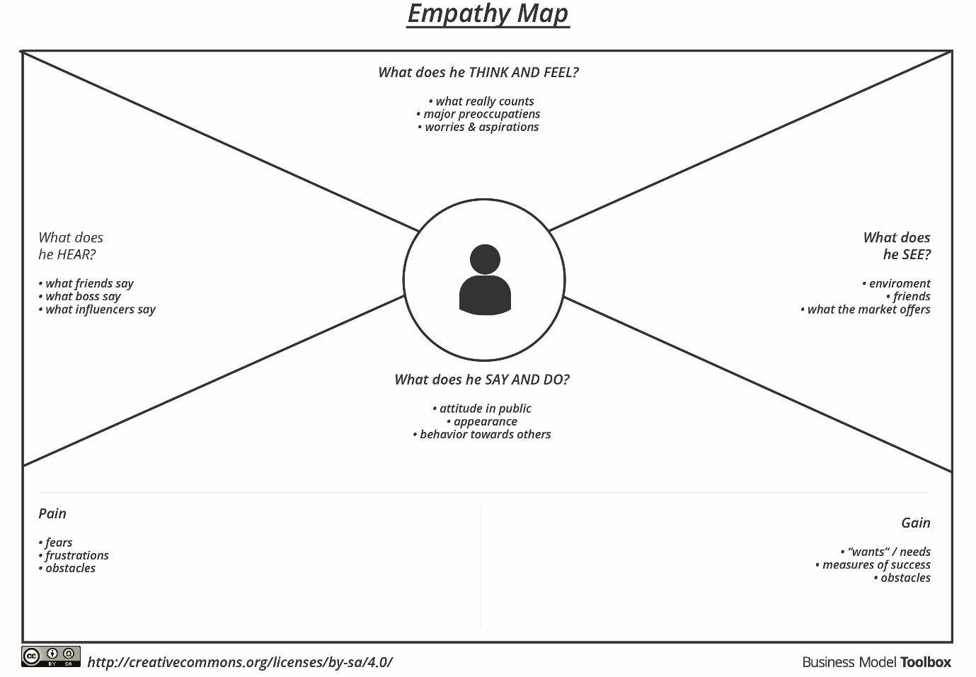

Reference: https://www.mural.co/templates/empathy-map-canvas

Example: Food Ordering & Delivery Application
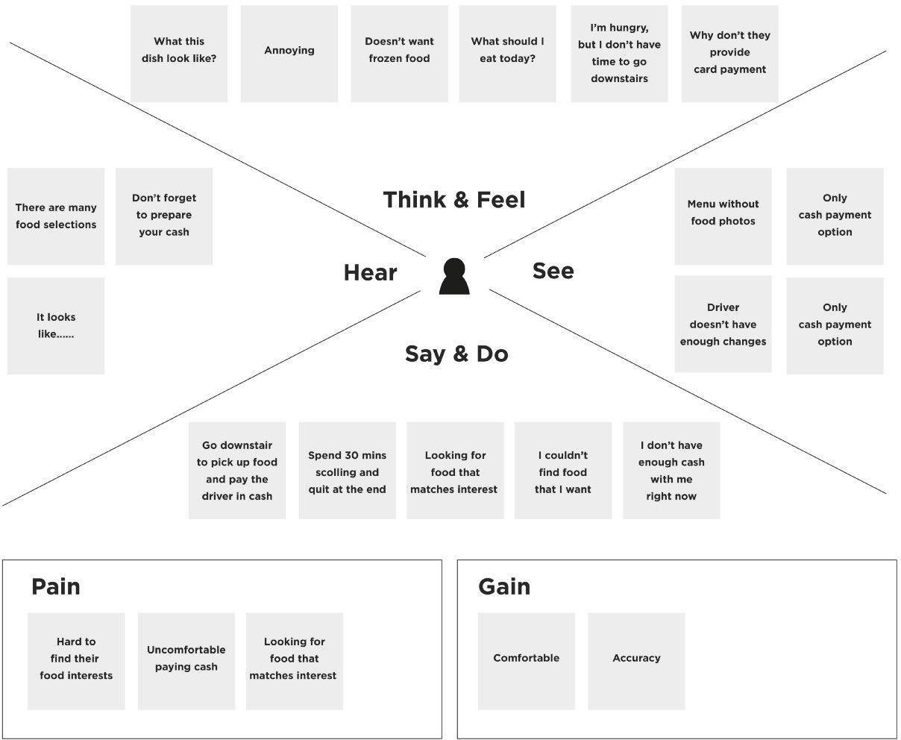

Empathy Map Canvas (DarshanEase User – Temple Devotee) THINK & FEEL
- Worried about long waiting queues at temples
- Wants a peaceful and organized Darshan experience
- Concerned about temple crowd during festivals
- Prefers planning the visit in advance
- Wants trustworthy information about temple timings

SEE

- Large crowds and long lines at famous temples
- Devotees waiting for hours for Darshan
- Limited digital facilities in many temples
- Different websites showing incomplete temple information
- Increasing use of mobile apps for travel and bookings

HEAR

- Friends and family complaining about long waiting times
- People suggesting to visit temples early morning to avoid crowds
- Temple announcements regarding crowd control
- Discussions about online booking systems used in some temples

SAY & DO

- Searches temple information online
- Asks others about best time to visit
- Travels long distances to reach temples
- Waits in long queues for Darshan
- Wishes there was an easier online booking system

PAIN

- Long waiting time for Darshan
- Overcrowded temple premises
- Lack of reliable temple information online
- No proper digital system for booking Darshan slots
- Inconvenient donation methods

GAIN

- Ability to book Darshan slots online
- Reduced waiting time at temples
- Easy access to temple details and facilities
- Secure and transparent donation system
- Better and organized pilgrimage experience

